**World Rank of a University**

**Rohit Kamat**

**May 13, 2016**

**SDS 358**



**Introduction**

**Objectives:** Investigate the significance of greater proportion of variance on Alumni Score and Awards Score have on the total score for determining the world rank of a university, when controlling for Nature and Science Score and PUB Score. Since I was a Junior in high school, I have been curious on what factors caused certain universities to be ranked higher than others.

**Hypotheses:** Alumni and Award score does account for a significant greater proportion of variance for determining the world rank of a university when controlling for Nature and Science Score and PUB Score.

**Methods**

**Sample:** Subjects were the top 100 World Universities from each year from 2005 to 2015. The total score of universities (quantitative), alumni score (quantitative), award score (quantitative), nature and science score (quantitative), and PUB score (quantitative) were measured. After tagging the observation that I will use for the model, I had 1101 samples. From using the three outs method, I had 18 outliers that were removed.

**Analysis Method:** A sequential multiple regression was performed.

**Descriptives**

**Response Variable:**

|  |  |  |  |  |
| --- | --- | --- | --- | --- |
|  | **Mean** | **SD** | **Min** | **Max** |
| **Total Score** | 36.38 | 13.56 | 23.5 | 100 |

**Explanatory Variables:**

|  |  |  |  |  |
| --- | --- | --- | --- | --- |
|  | **Mean** | **SD** | **Min** | **Max** |
| **NS Score**  **(Control Variable)** | 16.08 | 12.51 | 0 | 100 |
| **PUB Score**  **(Control Variable)** | 38.25 | 13.05 | 7.3 | 100 |
| **Alumni Score** | 9.16 | 14.14 | 0 | 100 |
| **Award Score** | 7.69 | 15.49 | 0 | 100 |

**Results**

**Overall Significance of Variance Change:**

|  |  |  |  |  |
| --- | --- | --- | --- | --- |
| **Model** | **RSS** | **Df** | **F-value** | **P-value** |
| **Control Variables** | 24598.20 |  |  |  |
| **+ Variables of Interest** | 2892.30 | 2 | 4045.1 | <.001 |

**Regression Table:**

**Model 1 (Just Control Variables):**

|  |  |  |  |  |
| --- | --- | --- | --- | --- |
| **Coefficient** | **Estimate** | **SE** | **t-value** | **P-value** |
| **Intercept** | 5.32279 | .66173 | 8.044 | <.001 |
| **NS** | 0.76845 | .01287 | 59.073 | <.001 |
| **PUB** | 0.10881 | .01541 | 7.062 | <.001 |

Overall Model Fit: F(2,1080)= 3544, p<.001; Multiple R2= 0.8678, Adjusted R2 =0.8675

**Model 2 (With Variable of Interest)**

|  |  |  |  |  |
| --- | --- | --- | --- | --- |
| **Coefficient** | **Estimate** | **SE** | **t-value** | **P-value** |
| **Intercept** | 1.244374 | .238944 | 5.208 | <.001 |
| **NS** | .410574 | .006180 | 66.436 | <.001 |
| **PUB** | .24210 | .005943 | 40.741 | <.001 |
| **Alumni** | .109702 | .004260 | 25.753 | <.001 |
| **Award** | .218962 | .004365 | 50.166 | <.001 |

Overall Model Fit: F(4,1078) = 1.074 * 104, p < 0.001; Multiple R2 = 0.9845, Adjusted R2= 0.9844

**Difference of Variance between Variables of Interest and Control Variables**: 0.1166785

**Assumptions**

**Assumptions:** To check for multicollinearity I used the Variation Inflation Factor (VIF). The Variance Inflation Factor for all variables was under 5, so there was no multicollinearity in the model. A Residual vs. Fitted Plot was used to check and confirmed Homoscedasticity. Cook’s Distance Plot and the use of Three Outs was used to determine outlier removal.

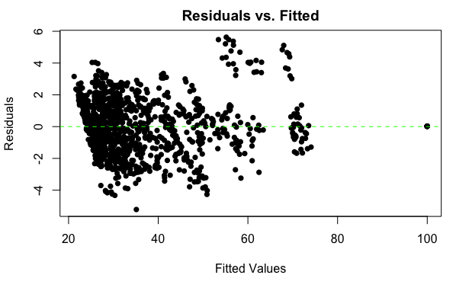

**Discussion**

**Interpretation:** Thevariance change from the first model to the second model was significant with F(2,1078)= 4045.1, p<.05. Difference of variance between the variable of interest and the control variables is 0.1166785. The overall full model (second model) was significant with F(4,1078)= 1 * 104, p<.05. The individual slopes of the full model showed a positive impact on the total score of a university ranking for NS Score (β=0.410574, t(1078)=66.436, p<.05), PUB Score (β=0.242120, t(1078)=40.741, p<.05), Alumni Score (β=0.109702, t(1078)=25.743, p<.05), Award Score (β=0.218962, t(1078)=50.166, p<.05).

**Limitations:** The model did not take into account other factors that impact the total score of a university such as the HiCi Score and the PCP score.

**Implications:** Several indicators for determining the rank of a university were based on research, papers published and awards based on staff members and alumni from the institution. I think factors related to the students such as employment of graduates, quality of professors, value of degree from the school in terms of income, graduation rate should also determine the rank of the university.

**References**: The methodology and use of the Academic Ranking of World University website. http://www.shanghairanking.com/